|  |  |  |  |  |  |
| --- | --- | --- | --- | --- | --- |
| Date | 12-Dec-22 | | | Tester Name | Janette Paus |
| Environment | Penfax - Test 2 | | | Login used | <If different from the Tester> |
| Operating System | Windows | Version: 21H2 | Update Number: | | |
| Software Used | Select Software | Version: 107.0.1418.56 | Update Number: | | |
| Select Software | Version: | Update Number: | | |
| Application Release version | R22.4.1 | | | | |
| Test Case Title | E13.04 | | | | |
| Test Type | Regression | | | | |
| Test Scenario | Add a VPB Specified Beneficiary | | | | |
| Expected Results | The new PEPP beneficiary is added correctly and is reflected in PENWEB. | | | | |
| Pass/Fail | Pass | | | JIRA# |  |

Search for any VPB member that do not have primary VPB Specified beneficiary listed yet.

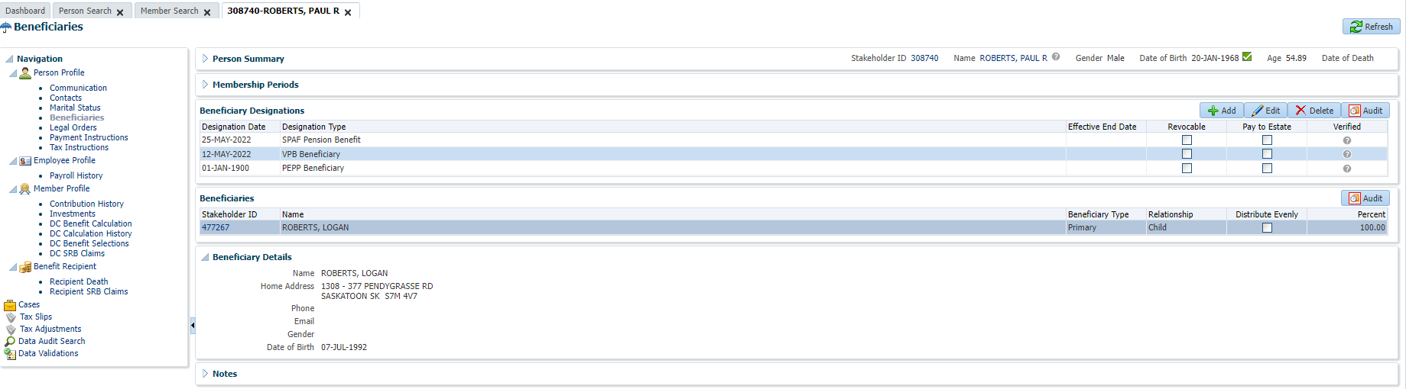

Open that member profile, Under person profile🡪 Beneficiary🡪 Beneficiary Designations

Add beneficiary designation 🡪 click Edit, then click Add

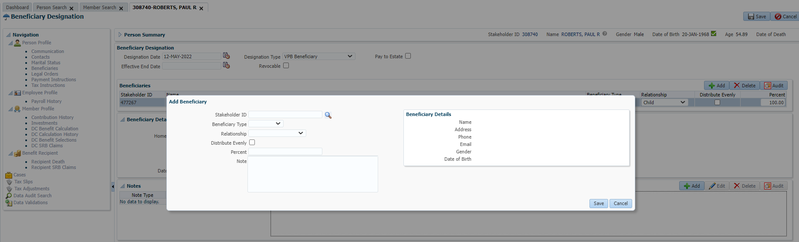

Add beneficiary details or search for beneficiary

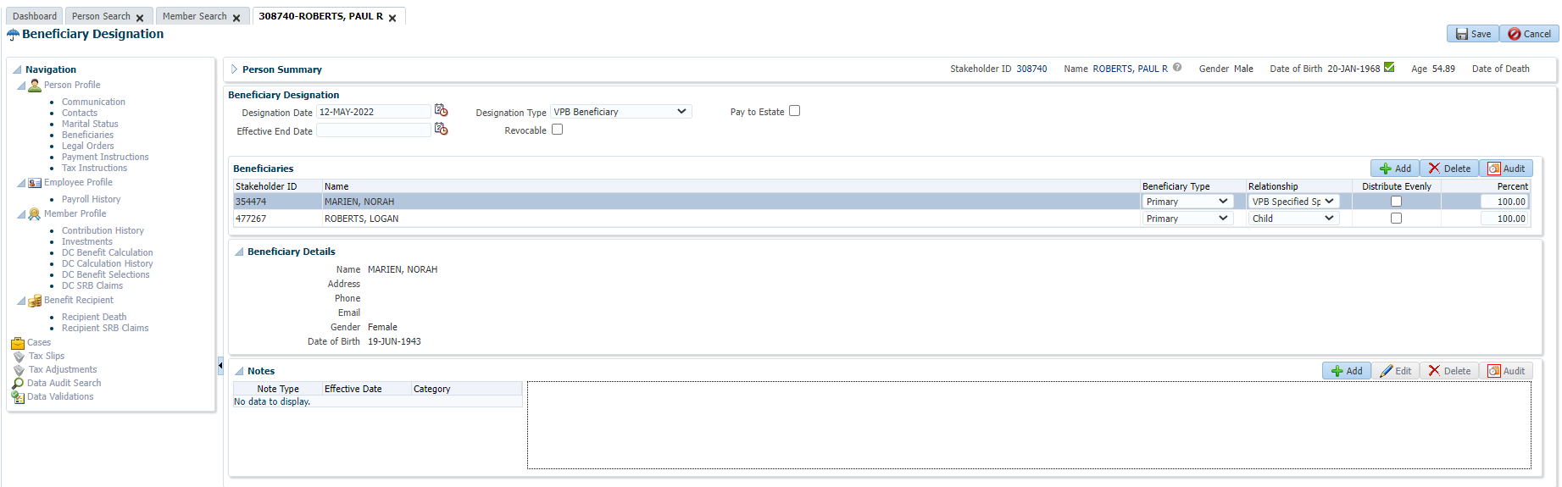

Here, new beneficiary details are added and then save the details.

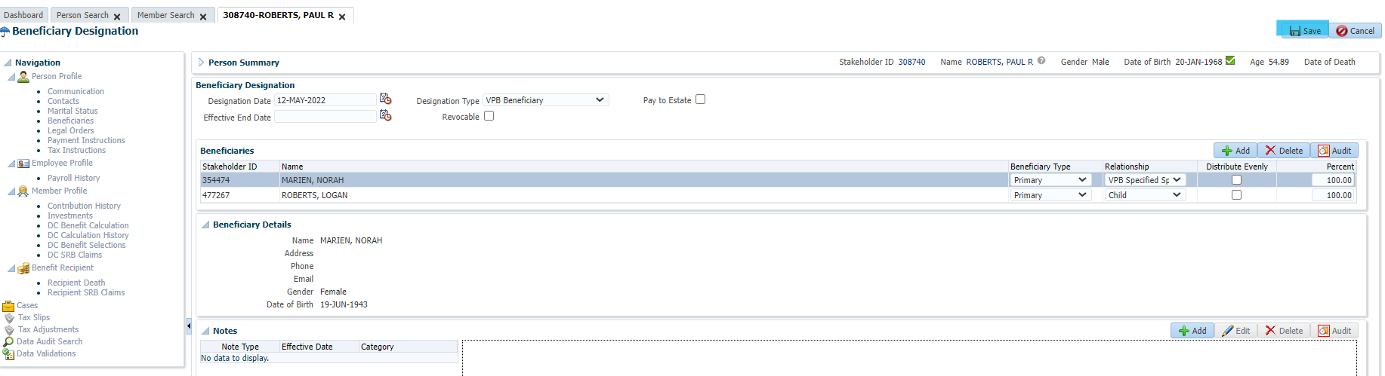

Add Beneficiary Type🡪 Trustee and Relationship and then save the details.

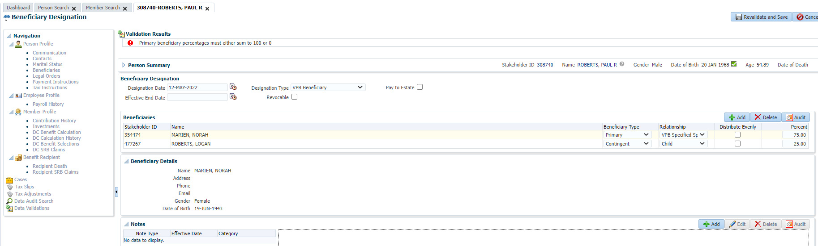

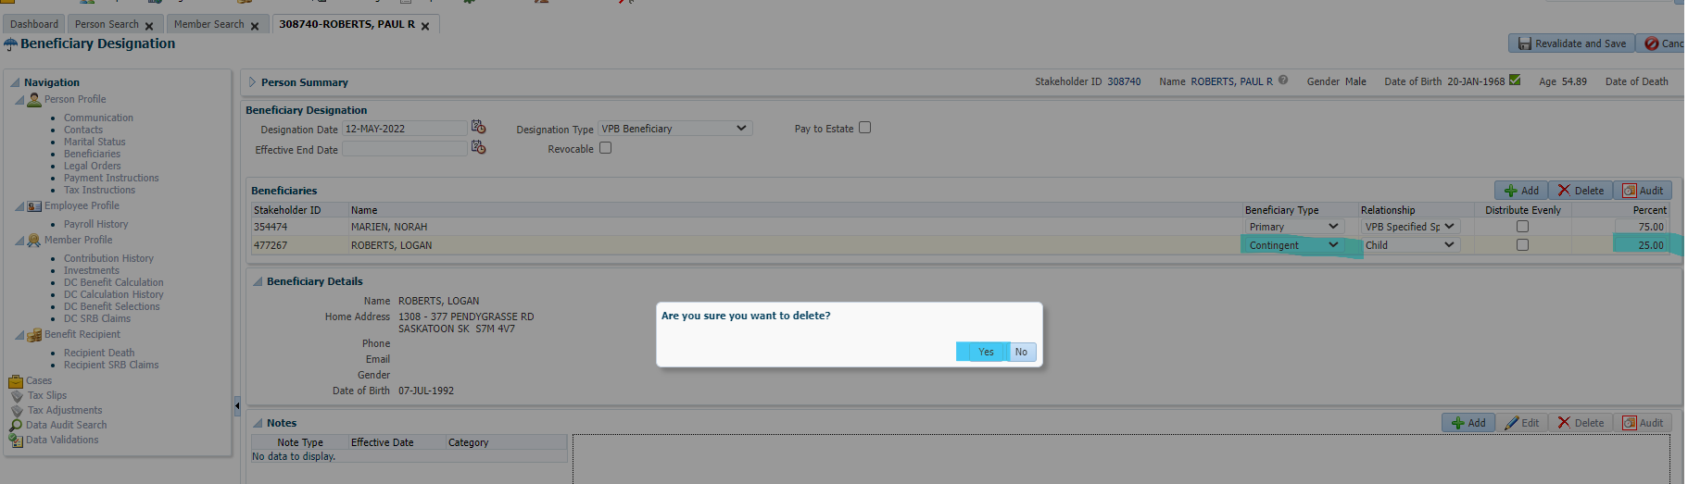

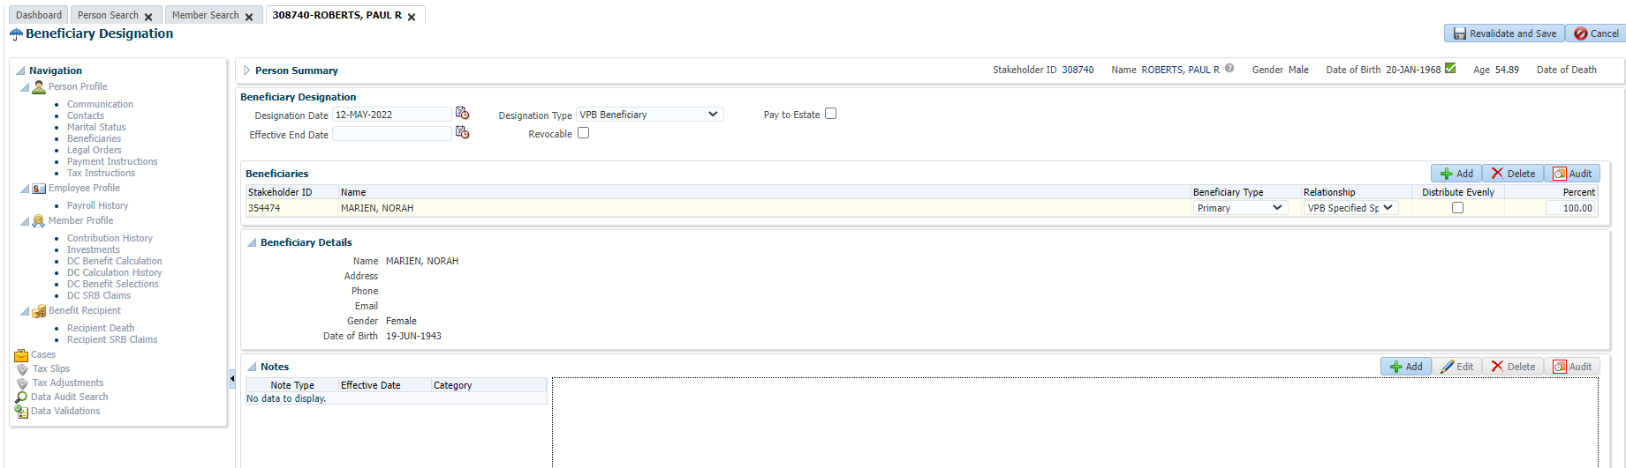

Enter Designation Date, Designation Type and hit save button at the top right corner.

New VPB Specified beneficiary is added

